**AIM: To implement classification, clustering, association mining using WEKA explorer.**

**THEORY:**

**CLASSIFICATION:**

**STEPS:**

1. Open Weka explorer.
2. In preprocess section click OPEN search your desired dataset.
3. Now click on the Classify Tab of WEKA.
4. Click on CHOOSE and choose a desired classification method(Here Decision Tree or DecisionStump).
5. You can change the test options as you want. Select an attribute to classify(Here (Nom) play) after doing that click on START and the dataset will be classified.

**OUTPUT:**

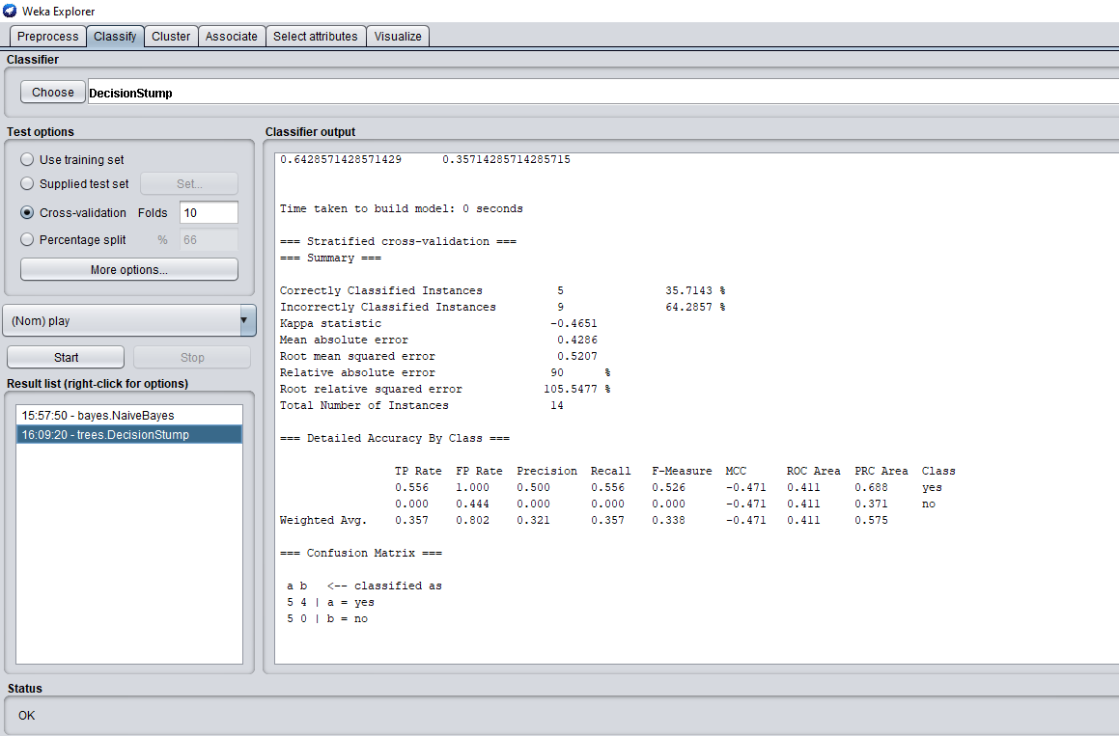

**Figure 1: Classify option in WEKA**

**CLUSTERING:**

**STEPS:**

1. Open Weka explorer.
2. In preprocess section click OPEN search your desired dataset.
3. Now click on the Cluster Tab of WEKA.
4. Click on CHOOSE and choose a desired clustering method(Here SimpleKMeans).
5. You can change the test options as you want after doing that click on START and the dataset will be clustered.

**OUTPUT:**

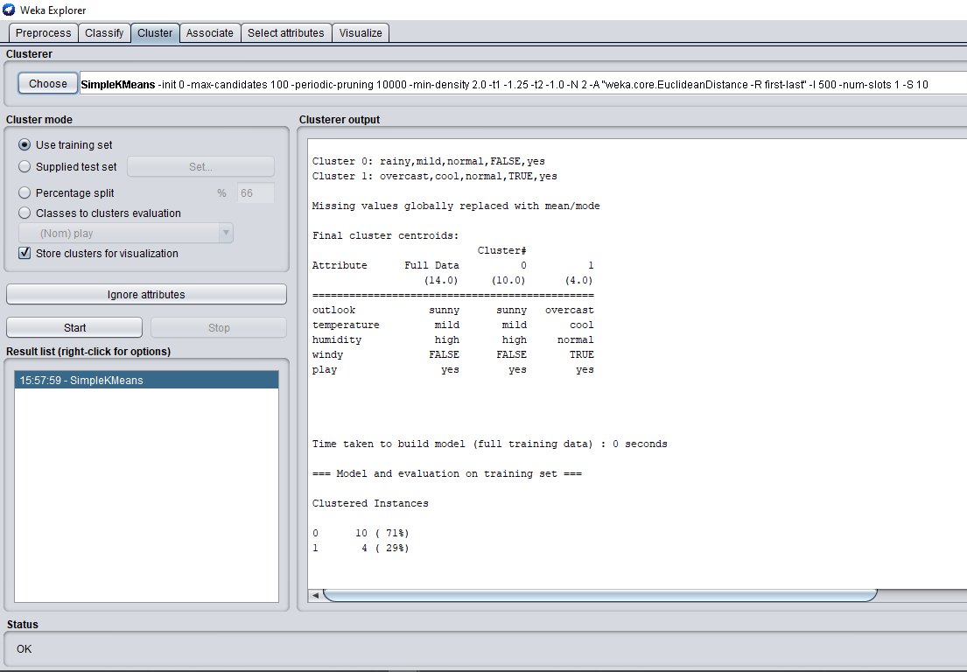

**Figure 2: Cluster option in WEKA**

**ASSOCIATION MINING:**

**STEPS:**

1. Open Weka explorer.
2. In preprocess section click OPEN search your desired dataset.
3. Now click on the Associate Tab of WEKA.
4. Click on CHOOSE and choose a desired association method(Here Apriori).
5. You can change the test options as you want after doing that click on START and the dataset will be clustered.

**OUTPUT:**

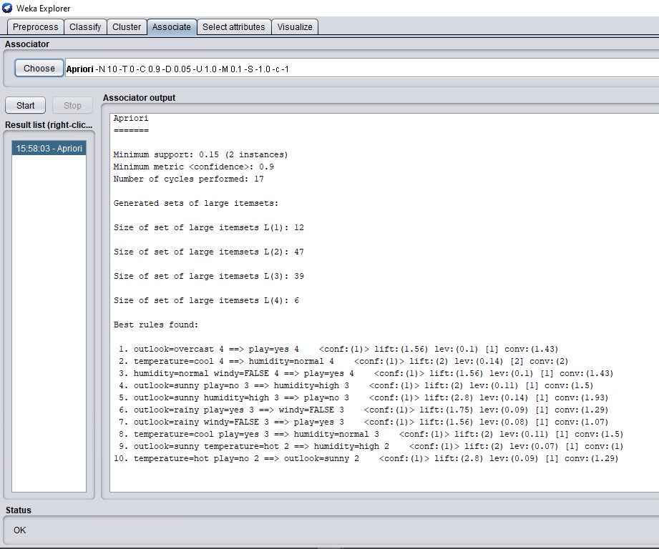

**Figure 3: Associate option in WEKA**

**CONCLUSION:**

From this experiment we learnt about WEKA software which can easily implement machine learning on the datasets given to it. We understood the layout of the software and first saw the Pre process tab where we import the dataset and see its features. Then we performed classification using Decision tree, clustering using Simple Kmeans and association mining using Apriori algorithm by going to Classify , Cluster and Associate tab of WEKA.